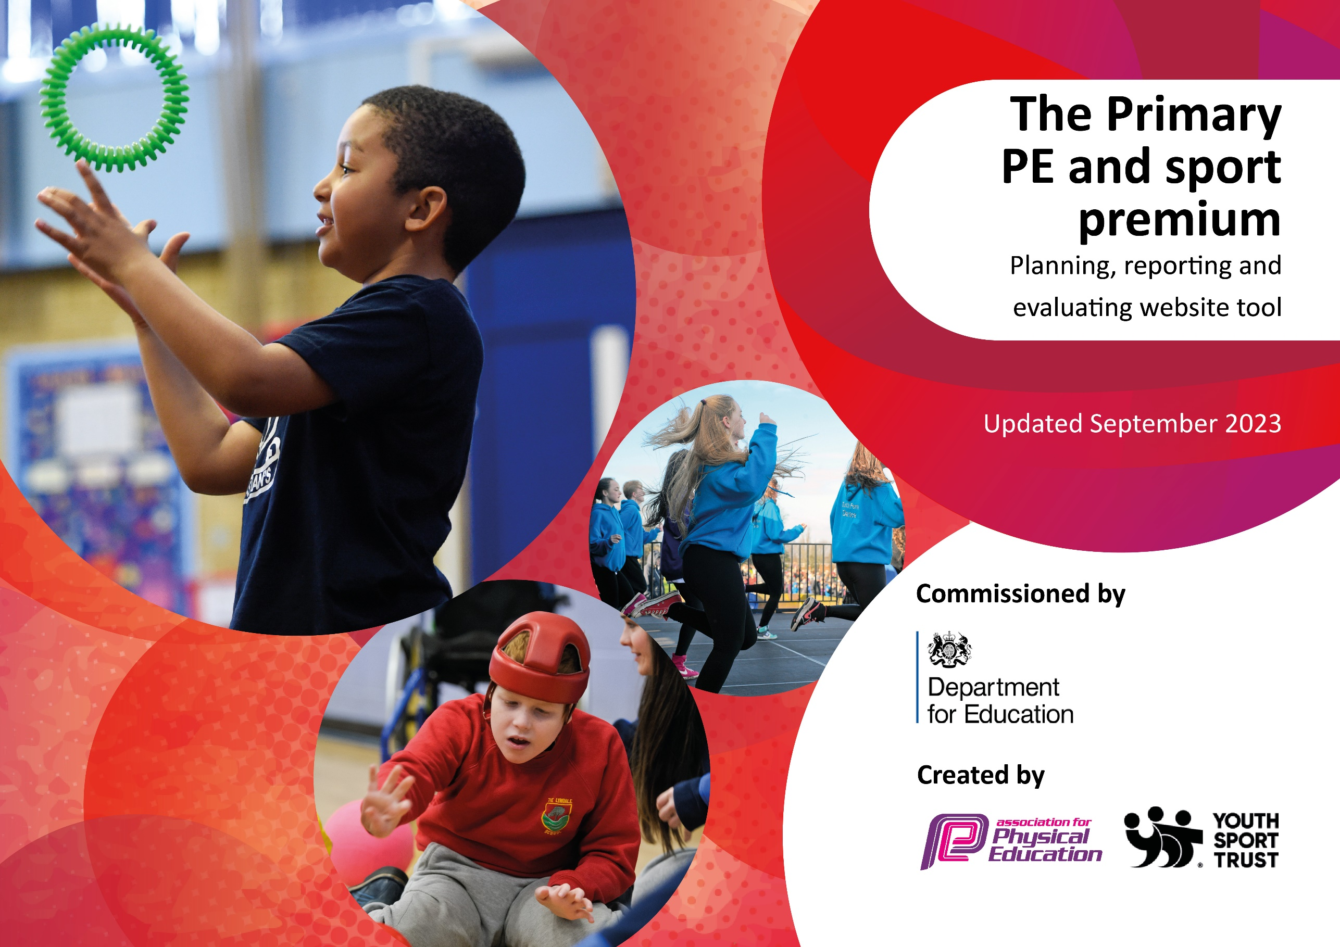

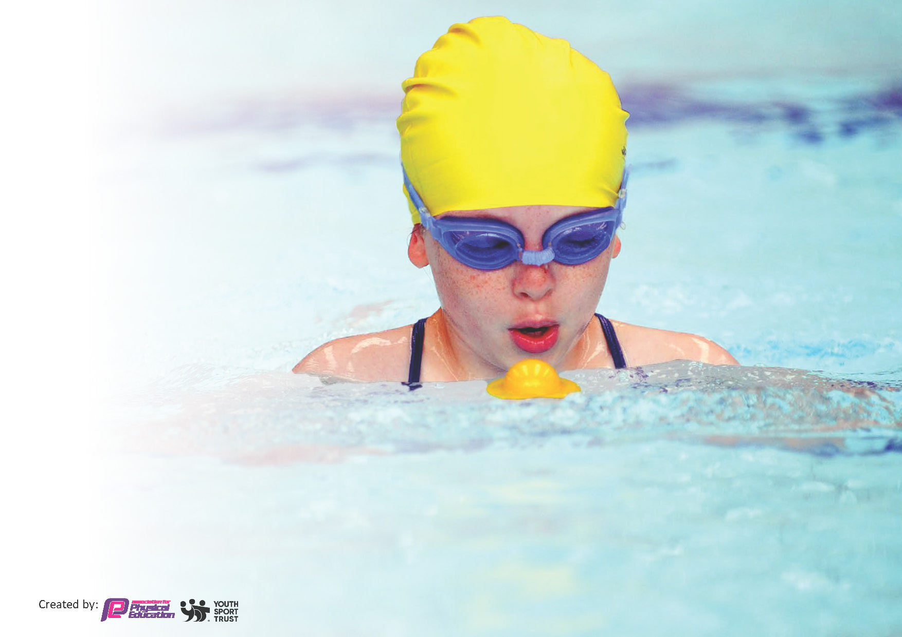
This template can be used for multiple purposes:
by:
- It enables schools to effectively plan their use of the Primary PE and sport premium
- It helps schools to meet the requirements (as set out in guidance) to publish information on their Primary PE and sport premium
- It will be an effective document to support Ofsted inspections enabling schools to evidence progress in Physical Education (PE) and evidence swimming attainment, which forms part of the PE National Curriculum. We would recommend schools consider
the Intent, Implementation and Impact of any spend, as examined within the Education Inspection Framework.

It is important that your grant is used effectively and based on school need.

Schools must use the funding to make additional and sustainable
improvements to the quality of the PE, School Sport and Physical Activity (PESSPA)
they offer. This means that you should use the Primary PE and sport premium to:

- Build capacity and capability within the school to ensure that improvements made now will benefit pupils joining the school in future years
- Develop or add to the PESSPA activities that your school already offers.

The Primary PE and sport premium should not be used to fund capital spend projects; the school’s core budget should fund these. Further detail on capital expenditure can be found in the updated Primary PE and sport premium guidance.

The Primary PE and sport premium guidance, outlines 5 key priorities that funding should be used towards. It is not

necessary that spending has to meet all the key priorities, you should select the priorities that you aim to use any funding towards.

Although completing this template is not a requirement for schools, schools are required to publish details of how they spend this funding. Schools must also outline what the impact this funding has had on pupils’ PE and sport participation and attainment and how any spending will be sustainable in the future. All funding must be spent by 31st July 2024.

The Department for Education has worked closely with the Association for Physical Education (afPE) and the Youth Sport Trust (YST) to develop this template and encourages schools to use it. This template is an effective way of meeting the reporting requirements of the Primary PE and sport premium.
Review of last year’s spend and key achievements (2023/2024)

We recommend you start by reflecting on the impact of current provision and reviewing your previous spend.

Activity/Action | Impact | Comments
Ensure all classes have access to specialist teachers. | Pupils are more often being taught by specialist teachers. This has led to greater enjoyment, engagement and progress in P.E.  Analysis of class teachers’ skillsets- ensuring specialists are supporting teachers in areas of P.E where they are less confident. This has helped to upskill all teaching staff. | CPD needs to be identified and look for courses.

Key priorities and Planning

This planning template will allow schools to accurately plan their spending.

Action – what are you planning to do | Who does this action impact? | Key indicator to meet | Impacts and how sustainability will be achieved? | Cost linked to the action
Total Allocation: £18,010

Total planned spend: £17,192
To fully engage children in physical activity and sport with the use of high-quality PE lessons utilising good quality resources.  Purchase of new PE scheme of work for primary.  To encourage EYFS children to be confident in the outdoors.  To provide children with experiences involving outdoor education and to improve wellbeing and activity across the primary school. With the aim of providing children with lifelong skills that will allow them to stay active such as map reading, SUP boarding, den building and canoeing.  To ensure high quality resources for playtimes which encourage physical activity.  School Facebook regularly updated to celebrate the sporting achievements of our pupils and to raise awareness of activities happening within school.  To appoint Y6 sports leaders and identify these pupils for others to see.  To recognise successes of all pupils during sports day  Increase confidence of non-specialist teachers.  To continue to improve hand eye coordination and gross motor skills and fully prepare them for potential competitions in the future.  To explore new curriculum providers as a means to gauge increased interest from the children and to provide staff with further opportunities to share and observe best practice.  To encourage team spirit and confidence by providing quality team kit to pupils.  To affiliate to any necessary associations.  To ensure a broad offer of extra-curricular clubs are on offer for pupils. | RED/DEC/AT- conduct audit of resources and purchase any equipment which may be needed.  Discuss with staff- link to long term plan for primary P.E.  RED to purchase Get Set 4 PE scheme of work.  EYFS staff- JB to lead.  Reception pupils have access to quality outdoor areas- funding from main school fund/PTA funds.  Pupils are active and building fine/gross motor skills through well planned activities.  RED/KS to liaise with KG to book in sessions from R- Y4.  Ensure pupils have access to range of different outdoor activities across year groups.  Pupils are engaged in physical activity during break/lunchtimes.  A wider variety of games/equipment available to pupils.  Age appropriate equipment from R-Y6.  Staff are proactive in supporting good play ad helping pupils be active.  Organisation of playground- KS to look at SJB- Opal plyagrounds.  Updates shared around variety of sports events/competitions;  Netball  Basketball  Football  Tag Rugby  Swimming  Gymnastics  Successes/results shared in celebration assemblies with the rest of the school.  Out of school achievements celebrated- medals, certificates, ribbons etc to give sport and competition a prominent place in school life.  Active/’sporty’ pupils given prominent role in promoting school sport and P.E.  Work with supervising adults to co-ordinate games/activities for younger pupils.  All pupils feel sense of achievement/positivity around Sports Day activities.  Still give prizes for 1st, 2nd, 3rd to maintain competitive element, especially for those pupils who excel.  Identify pupils who excel and encourage them to participate in clubs/competitions next academic year to enhance Chetwynde’s sporting prowess.  DE (specialist teacher) has continued to teach across primary, alongside staff. Staff work with DE to upskill themselves.  A range of coaches/external providers have been in school to work with classes from K-Y6, alongside class teachers.  Pupils have access to high-quality P.E curriculum with specialist teacher.  Class teachers are able to work with smaller groups of pupils or look at assessing skills/progression.  More pupils at age expectations for their year group.  More pupils accessing sports clubs/teams.  Staff can see a visible improvement to pupil’s attainment.  Coaches/external providers can explain to staff what/why they are using the games/activities they are for their class.  Pupils have access to wider range of sports/activities.  Increased enjoyment and uptake in extra-curricular clubs.  Staff have wider CPD by observing and team-teaching different activities.  Ensure pride in representing Chetwynde.  Promote teamwork and responsibility.  Ensure pupils feel like ambassadors to the school.  Affiliate with any necessary organizations to ensure Chetwynde have the same access and opportunities to CPD, festival and competitions across Furness area.  Complete the School Games mark.  Pupils are offered sporting opportunities after school.  Any paid clubs/coaches will be met by the Sport Premium to allow access for all.  Staff invited to run clubs for a term each- half a day in lieu offered. | Key indicator 2 -The engagement of all pupils in regular physical activity – the Chief Medical Officer guidelines recommend that all children and young people aged 5 to 18 engage in at least 60 minutes of physical activity per day, of which 30 minutes should be in school.  Key indicator 2 -The engagement of all pupils in regular physical activity – the Chief Medical Officer guidelines recommend that all children and young people aged 5 to 18 engage in at least 60 minutes of physical activity per day, of which 30 minutes should be in school.  Key indicator 4- Broader experience of a range of sports and activities offered to all pupils.  Key indicator 2 -The engagement of all pupils in regular physical activity – the Chief Medical Officer guidelines recommend that all children and young people aged 5 to 18 engage in at least 60 minutes of physical activity per day, of which 30 minutes should be in school.  Key indicator 4- Broader experience of a range of sports and activities offered to all pupils.  Key indicator 2 -The engagement of all pupils in regular physical activity – the Chief Medical Officer guidelines recommend that all children and young people aged 5 to 18 engage in at least 60 minutes of physical activity per day, of which 30 minutes should be in school.  Key indicator 2: The profile of PE and sport being raised across the school as a tool for whole school improvement.  Key indicator 2: The profile of PE and sport being raised across the school as a tool for whole school improvement.  Key indicator 2: The profile of PE and sport being raised across the school as a tool for whole school improvement.  Key indicator 3: Increased confidence, knowledge and skills of all staff in teaching PE and sport.  Key indicator 4- Broader experience of a range of sports and activities offered to all pupils.  Key indicator 3: Increased confidence, knowledge and skills of all staff in teaching PE and sport  Key indicator 2: The profile of PE and sport being raised across the school as a tool for whole school improvement.  Key indicator 4: Broader experience of a range of sports and activities offered to all pupils.  Key indicator 5: Increased participation in competitive sport  Key indicator 4: Broader experience of a range of sports and activities offered to all pupils.  Key indicator 5: Increased participation in competitive sport. | Pupils engaged in P.E lessons and pupils are more constantly active as appropriate levels of equipment are available for classes of pupils.  Pupils physically active for longer periods in lessons.  Enjoyment of P.E lessons increasing- pupil voice needs to be conducted in 24/25 academic year.  Improved fine/gross motor skills for reception pupils.  Engagement in outdoor learning/experiences.  Positive feedback from pupils and parents.  Look to further staff training opportunities to share responsibility across staff and allow more access for other year groups.  Pupils engaging with the range of activities on offer.  Development of skills including leadership, resilience, communication, teamwork etc which are essential to sports and can be transferred to other areas of the curriculum.  Costings have increased for this event from the providers due to increases.  Ensure School Council/Sport Leader consultation with any new equipment.  Look at more suitable storage options- open containers damaged too easily.  Bluetooth speaker for outdoors- dance?  Staff training/CPD for promoting physical play at lunchtimes.  SCMAT Facebook page sharing stories/posts as well- increased visibility.  Local press (The Mail) picked up a couple of stories- swimming successes.  Continue to remind staff to be proactive with posting sports related stories.  Encouraged pupils to bring any sports related achievements from out of school.  This resulted in a local newspaper story for one pupil who is representing GB in Karate.  Link to active playtimes- further work to ‘train up’ sports leaders to lead games/activities for younger pupils at lunchtimes.  Successful Sports Day with pupils feeling positive and enthused about P.E and sport.  Sports feedback needed with Sports Leaders- could we improve Sports Day?  ‘G&T’ list for athletics started ready for next academic year.  Pupil Feedback Survey needs completing-attitudes to P.E/sport.  Staff questionnaire needs completing- gaps in confidence/knowledge. Staff have mentioned dance/gymnastics. Look for CPD opportunities for these.  Look at implementing a P.E scheme which transitions into KS3.  Specialist teachers will continue to work with pupils. Focus on class teachers taking a lead in sessions and getting coaching/feedback from their specialist counterparts.  Review the coaching offer for 24/25- ensure different classes/teachers are being upskilled by external providers.  Ensure that high quality teaching is continued after initial input from coaches- monitoring of lessons.  Monitor club attendance- Edulink.  More pupils are able to access age appropriate activities/sports.  Chetwynde will be successful in future competitions.  Movin Monkee’s in for R class for fundamental skills.  Cricket coaching introduced in KS1.  24/25-Look to include yoga throughout- Y6 for SATS prep.  24/25-Tag Rugby introduced at KS2- link to club and competition.  Ensure coach availability doesn’t detract from the curriculum offer and ensuring coverage of curriculum and skills.  Audit of kits needed to ensure all teams have high quality kits to use.  Look for sponsorship from local businesses/parental businesses- letter out Sept 2025.  Sports Leaders to have some ownership of sports kits being designed/ordered.  Affiliation with BPSFA ended as organization folded.  Athletics affiliation paid.  24/25- new local offer for competitive/festival sport being headed up by SGOs based at Furness Academy- affiliation fee to be confirmed,  Allow School Games Mark to feed into priorities for next academic year.  Good participation levels at clubs;  R:  Y1:  Y2:  Y3:  Y4:  Y5:  Y6:  Whole School:  Sports/P.E Questionnaire- ask pupils what clubs they would like to be part of? Target those pupils who don’t attend any club. | £2000 annually allocated for replacement/replenishment of sports/P.E equipment.  £702- Get Set 4 PE scheme.  £250-for resources/consumables.  £660- TA support to maximise pupils’ access to Forest Schools (1.5 hours per week).  £4425 for all instructors, equipment etc.  £2000- transport.  £750  £0  £50- stickers/badges  Tennis- £1050  Cricket- £950  Barrow Community Trust- £2000  Yoga-£750  £550  £500- look for sponsorship from local business to offset this if possible.  Furness Sport Partnership- £600

Meeting National Curriculum requirements for swimming and water safety.
Swimming Data
Priority should always be given to ensuring that pupils can perform safe self-rescue even if they do not fully meet the first two requirements of the National Curriculum programme of study
Question | Stats: | Further context  Relative to local challenges
What percentage of your current Year 6 cohort can swim competently, confidently and proficiently over a distance of at least 25 metres?
What percentage of your current Year 6 cohort can use a range of strokes effectively [for example, front crawl, backstroke, and breaststroke]?

Priority should always be given to ensuring that pupils can perform safe self-rescue even if they do not fully meet the first two requirements of the National Curriculum programme of study

What percentage of your current Year 6 cohort are able to perform safe self-rescue in different water-based situations?
If your schools swimming data is below national expectation, you can choose to use the Primary PE and sport premium to provide additional top-up sessions for those pupils that did not meet National Curriculum  requirements after the completion of core lessons. Have you done this? | Yes/No
Have you provided CPD to improve the knowledge and confidence of staff to be able to teach swimming and water safety? | Yes/No

Signed off by:

Head Teacher: | (Name)
Subject Leader or the individual responsible for the Primary PE and sport premium: | Reece Edwards
Governor: | (Name and Role)
Date:

